\hat{ x }
\widehat{ x }
\check{ x }
\tilde{ x }
\widetilde{ x }
\acute{ x }
\grave{ x }
\dot{ x }
\ddot{ x }
\breve{ x }
\bar{ x }
\vec{ x }
\overline{ x }
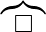
\overbrace{ x }

\overleftarrow{ x }
\overrightarrow{ x }
\overleftrightarrow{ x }
\overset{x}{y}{ x }
\underline{ x }

\underbrace{ x }

\underleftarrow{ x }
\underrightarrow{ x }
\underleftrightarrow{ x }
\underset{x}{y}{ x }
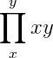
Normally \prod_{x}^{y}{x}{y} gives

but \textstyle \prod_{x}^{y}{x}{y} will give

Writing a matrix:
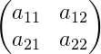
To write a matrix like
write
\begin{pmatrix}
a_{11} & a_{12} \\
a_{21} & a_{22}
\end{pmatrix}
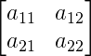
To write

write
\left[ \begin{matrix}
a_{11} & a_{12} \\
a_{21} & a_{22}
\end{matrix} \right]
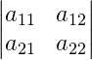
To write

write
\left| \begin{matrix}
a_{11} & a_{12} \\
a_{21} & a_{22}
\end{matrix} \right|

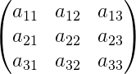
Higher order matrices can also be writen

\begin{pmatrix}
a_{11} & a_{12} & a_{13}\\
a_{21} & a_{22} & a_{23}\\
a_{31} & a_{32} & a_{33}
\end{pmatrix}

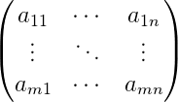
\begin{pmatrix}
a_{11} & \cdots & a_{1n}\\
\vdots & \ddots & \vdots\\
a_{m1} & \cdots & a_{mn}
\end{pmatrix}

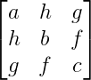
\left[ \begin{matrix}
a & h & g \\
h & b & f \\
g & f & c
\end{matrix} \right]

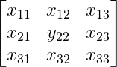
\left[ \begin{matrix}
x_{11} & x_{12} & x_{13} \\
x_{21} & y_{22} & x_{23} \\
x_{31} & x_{32} & x_{33}
\end{matrix} \right]

x_y x^y
\overset{x}{y} \underset{x}{y}

\frac{x}{y} \sqrt[x]{y} {x \atop y}

\sqrt{x}
\prod_{x}^{y} \textstyle \prod_{x}^{y} \coprod_{x}^{y}
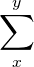
\textstyle \coprod_{x}^{y} \sum_{x}^{y}

\textstyle \sum_{x}^{y}

Brackets: \left( \right)
\left[ \right] \left\{ \right\} \left| \right|

Some Example:
\sqrt{a^2 + b^2}

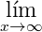
\lim_{x \to \infty }

\sqrt{b^2 - 4ac}

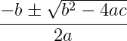
\frac{-b \pm \sqrt{b^2 -4ac} }{2a}

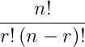
\frac{ n! }{ r! \left( n-r \right)! }
\frac{dy}{dx} \frac{\partial y}{\partial x}
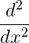
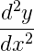
\frac{d^2 y}{d x^2} \frac{d^2 }{d x^2}

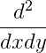
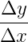
\frac{d^2 }{dx dy} \frac{\Delta y}{\Delta x}

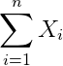
\sum_{i=1}^{n} X_i

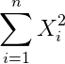
\sum_{i=1}^{n} X_i^2
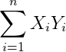
\sum_{i=1}^{n} X_i Y_i

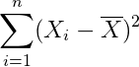
\sum_{i=1}^{n} (X_i - \overline{X} )^2

X_1, \dots, X_n

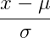
\frac{x - \mu }{ \sigma}

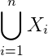
\bigcup_{i=1}^{n}{X_i}

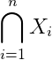
\bigcap_{i=1}^{n}{X_i}

\cos^{-1}\theta

\sin^{-1}\theta

e^{i \theta}
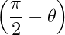
\left(\frac{\pi}{2}-\theta \right )

\overrightarrow{AB}

\overleftrightarrow{AB}

\widehat{AB}

\Delta A B C

_{10}^{5}C^{16}
2H_2 + O_2 \xrightarrow{n,m}2H_2O
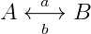
A\underset{b}{\overset{a}{\longleftrightarrow}}B

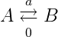
A\underset{0}{\overset{a}{\rightleftarrows}}B
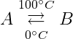
A\underset{0^{\circ}C }{\overset{100^{\circ}C}{\rightleftarrows}}B

\vec{F}=m\vec{a}

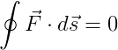
\oint \vec{F} \cdot d\vec{s}=0

\psi (t)=\hat{\psi}e^{i(\omega t\, \pm\, \theta)}

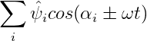
\sum_i \hat{\psi_i} cos(\alpha_i \pm \omega t)

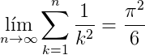
\lim_{n \to \infty}
\sum_{k=1}^n \frac{1}{k^2}
= \frac{\pi^2}{6}
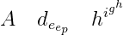
A \quad d_{e_{e_p}} \quad h^{i^{g^h}}

\forall x \in \mathbf{R}:
\qquad x^{2} \geq 0

x^{2} \geq 0\qquad
\text{for all }x\in\mathbf{R}

x^{2} \geq 0\qquad
\text{for all } x
\in \mathbb{R}

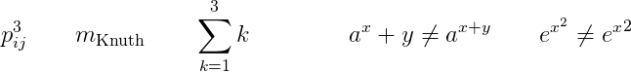
p^3_{ij} \qquad
m_\text{Knuth}\qquad
\sum_{k=1}^3 k \\[5pt]
a^x+y \neq a^{x+y}\qquad
e^{x^2} \neq {e^x}^2

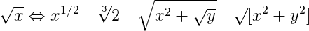

\sqrt{x} \Leftrightarrow x^{1/2}
\quad \sqrt[3]{2}
\quad \sqrt{x^{2} + \sqrt{y}}
\quad \surd[x^2 + y^2]

\Psi = v_1 \cdot v_2
\cdot \ldots \qquad
n! = 1 \cdot 2
\cdots (n-1) \cdot n

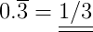
0.\overline{3} =
\underline{\underline{1/3}}
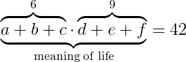
\underbrace{\overbrace{a+b+c}^6
\cdot \overbrace{d+e+f}^9}
_\text{meaning of life} = 42
f(x) = x^2 \qquad f’(x)
= 2x \qquad f’’(x) = 2\\[5pt]
\hat{XY} \quad \widehat{XY}
\quad \bar{x_0} \quad \bar{x}_0

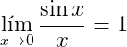
\lim_{x \rightarrow 0}
\frac{\sin x}{x}=1

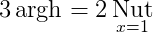
3\argh = 2\nut_{x=1}

a\bmod b \\
x\equiv a \pmod{b}

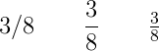
3/8 \qquad \frac{3}{8}
\qquad \tfrac{3}{8}
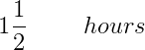
1\frac{1}{2} \qquad ~hours

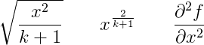

\sqrt{\frac{x^2}{k+1}}\qquad
x^\frac{2}{k+1}\qquad
\frac{\partial^2f}
{\partial x^2}
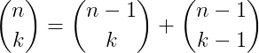

\binom{n}{k} =\binom{n-1}{k}
+ \binom{n-1}{k-1}

f_n(x) \stackrel{*}{\approx} 1

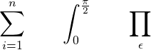
\sum_{i=1}^n \qquad
\int_0^{\frac{\pi}{2}} \qquad
\prod_\epsilon

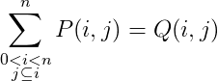
\sum^n_{\substack{0<i<n \\
j\subseteq i}}
P(i,j) = Q(i,j)

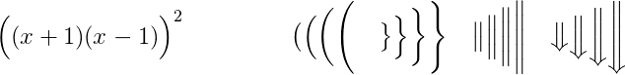
\Big((x+1)(x-1)\Big)^{2} \\
\big( \Big( \bigg( \Bigg( \quad
\big\} \Big\} \bigg\} \Bigg\} \quad
\big\| \Big\| \bigg\| \Bigg\| \quad
\big\Downarrow \Big\Downarrow
\bigg\Downarrow \Bigg\Downarrow

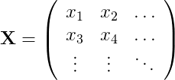
\mathbf{X} = \left(
\begin{array}{ccc}
x_1 & x_2 & \ldots \\
x_3 & x_4 & \ldots \\
\vdots & \vdots & \ddots
\end{array} \right)
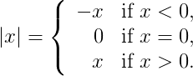
|x| = \left\{
\begin{array}{rl}
-x & \text{if } x < 0,\\
0 & \text{if } x = 0,\\
x & \text{if } x > 0.
\end{array} \right.
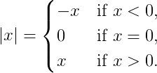
|x| =
\begin{cases}
-x & \text{if } x < 0,\\
0 & \text{if } x = 0,\\
x & \text{if } x > 0.
\end{cases}

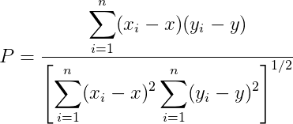
P = \frac{\displaystyle{
\sum_{i=1}^n (x_i- x)
(y_i- y)}}
{\displaystyle{\left[
\sum_{i=1}^n(x_i-x)^2
\sum_{i=1}^n(y_i- y)^2
\right]^{1/2}}}

\newcommand{\ud}{\,\mathrm{d}}
\int\int f(x)g(y)
\ud x \ud y \\
\int\!\!\!\int
f(x)g(y) \ud x \ud y \\
\iint f(x)g(y) \ud x \ud y
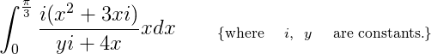

\int_{0}^{\frac{\pi}{3}} \frac {i(x^2+3xi)} {yi+4x} {xdx} \qquad
_{\text \{ \text {where} \quad
{i}, \text { } \text { } {y} \quad
\text {are constants.} \} }
Setting the Environment:
“miktex_path.bat”
@echo off
path=C:\Program Files\MiKTeX 2.9\miktex\bin\x64;C:\Program Files (x86)\gs\gs9.05\bin;%path%;
cmd
@echo on
Converting equation to SVG:
latex Sample.tex
dvisvgm --no-fonts Sample.dvi Sample.svg

Document Creation: example.tex
\documentclass{article}
\usepackage[utf8]{inputenc}
\usepackage{amsmath}
\usepackage{amsfonts}
\usepackage{amssymb}
\usepackage[spanish]{babel}
\usepackage{color}
\usepackage[T1]{fontenc}
\DeclareMathOperator{\argh}{argh}
\DeclareMathOperator*{\nut}{Nut}
\pagestyle{empty}
\begin{document}
\begin{huge}
\[\int_{0}^{\infty} x^2 x dx\]

\end{huge}
\end{document}
Useful Programs:
basic-miktex-2.9.5105-x64.exe http://miktex.org
dvisvgm-1.5.3-win64.zip http://dvisvgm.sourceforge.net
texmakerwin32_install.exe http://www.xm1math.net/texmaker/
texmaths-0-39.oxt http://roland65.free.fr/texmaths/index.html
http://extensions.libreoffice.org/extension-center/texmaths-1
latexee101.zip (Windows only) http://sourceforge.net/projects/latexee/
latexeqedit-0.4.zip (Windows only) http://latexeqedit.sourceforge.net/index.php
Installer-Equalx-0.7.0_64.exe (Windows, Linux) http://equalx.sourceforge.net/index.html
THRYSOEE.DK http://www.thrysoee.dk/laeqed/

